Integrated Aero-Electromechanical Optimization of a Shrouded Fan
Danish Galebotswe, Nathan Lee, Irvin Ma

Table of Contents
Introduction 4
Optimization Formulation and Product Modeling 5
Design Variables 5
Constraints 6
Objective 7
Volumetric Flow Rate of Air: Q 7
Airfoil Selection 7
Technical Background 9
Latin Hypercube Sampling 9
Methodology 9
Rationale for Use 10
Application to Fan Optimization 10
Limitations of Sampling Integer Design Variables 11
Loss of Stratification 11
Non-Uniform Distribution of Blade Counts 11
Clustering Effects in the Design Space 11
Implications for Analysis and Optimization 11
Gaussian Process Optimization Framework 12
Data Preprocessing and Normalization 12
Gaussian Process Model Definition and Training 12
Expected Improvement-Based Optimization 13
Global Optimization of the Acquisition Function 13
Bayesian Optimization as an Improvement to the GP Optimization Framework 14
Motivation for Bayesian Optimization 14
Bayesian Optimization Implementation 14
Analysis Models 16
Computational Fluid Dynamics 16
Simulation Inputs(Design Variables) 16
Airfoil Parameters 16
Fan Parameters 16
Simulation Mesh(Objective Function) 16
Simulation Boundary Conditions 17
Simulation Outputs(Objective Function) 18
Analysis of Results 19
Identification of Optimal Design 19
Differential Evolution Training of the Gaussian Process Surrogate Model 19
Verification and Validation 22
Verification of Numerical Implementation 22
Validation of Result 22
Testing of Scenarios 24
Conclusion and Future Work 24
References 26
Statement of Using AI Tools 27
Appendix 28

Table of Figures
Figure 1. Floor Plan of the GRAY Chicago Art Gallery …………………………………………… 4
Figure 2. Fan Example - Ceiling Fan ………………………………………………………………. 4
Figure 3. Airfoil Parameters Demonstration ……………………………………………………….. 5
Figure 4. Fan Size Parameters in Model ………………………………………………….. ………. 6
Figure 5. Example Airfoil Generation ……………………………………………………………... 8
Figure 6. The sample points of some of the design variables ……………………………………… 10
Figure 7. Sample of the Number of Blades ………………………………………………………… 12
Figure 8. Dynamic Pressure Contour along the mid plane ………………………………………… 20
Figure 9. Dynamic Pressure Contour on the Surface of the fan blades and the shroud …………… 20
Figure 10. Velocity Pathlines in Moving Reference Frame ……………………………………….. 21
Figure 11. Volumetric Flow Rate of Different Samples …………………………………………… 21
Figure 12. Dynamic Pressure Contour along the Mid-Plane ……………………………………… 23
Figure 13. Dynamic Pressure Contour on the Surface of the Fan Blades and the Shroud ………… 23

Table of Tables
Table 1. Boundary Conditions specified to named selections following meshing ………………… 17

Introduction
Our Client, Nick Raffel, is designing a system that aims to maximize the circulation of air in the GRAY Chicago art gallery. Looking to incorporate a fan that directs air towards the return vent in the rear of the room(Figure xx1), Nick requested an efficient fan blade design that is able to provide maximum volumetric airflow.
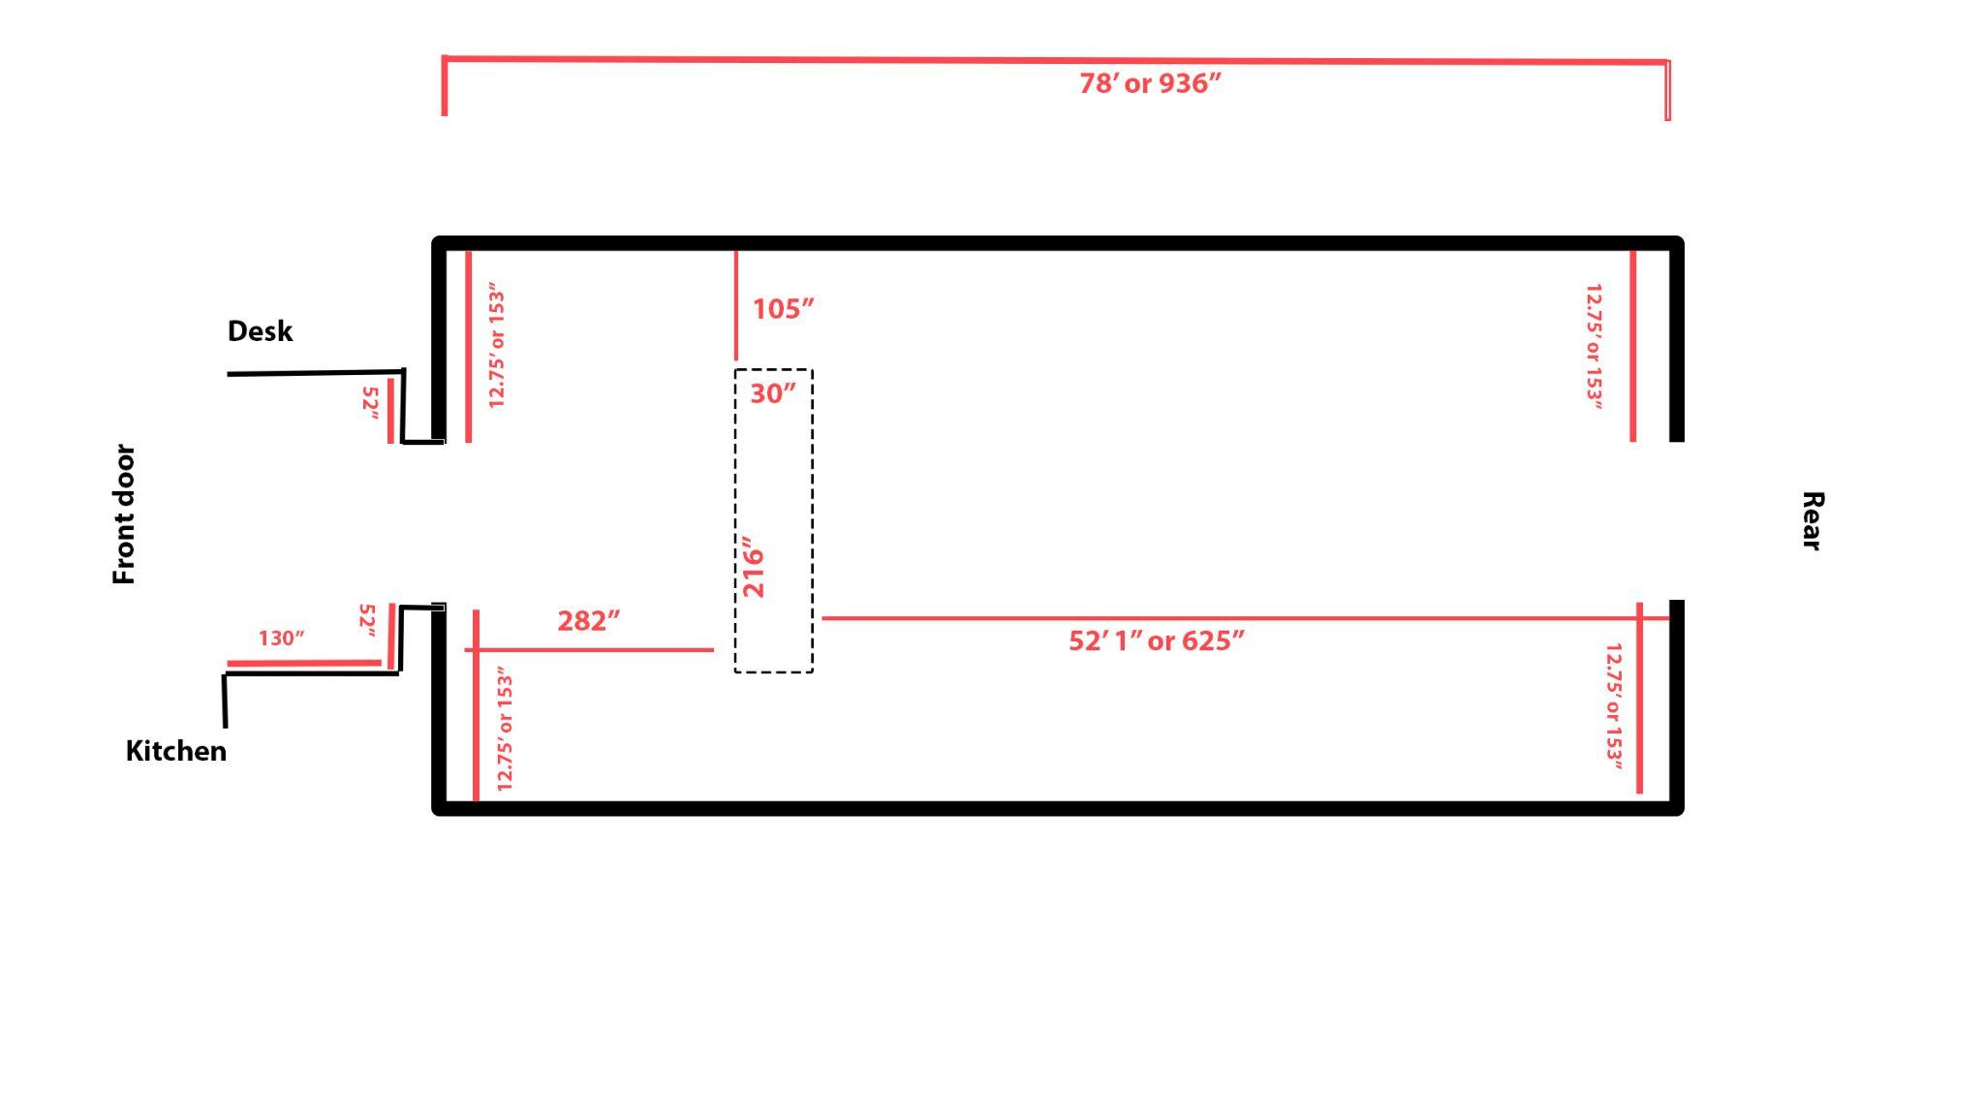
Figure 1: Floor Plan of the GRAY Chicago Art Gallery

If someone were to look up at a fan, he/she will notice that the fan blade isn’t a simple shape. Instead, most traditional fan blades incorporate a curved, 3 dimensional design with the concave face facing in the direction of the airflow. He/she will also see that the entire blade twists as it branches out from the hub of the fan(Figure xx2).
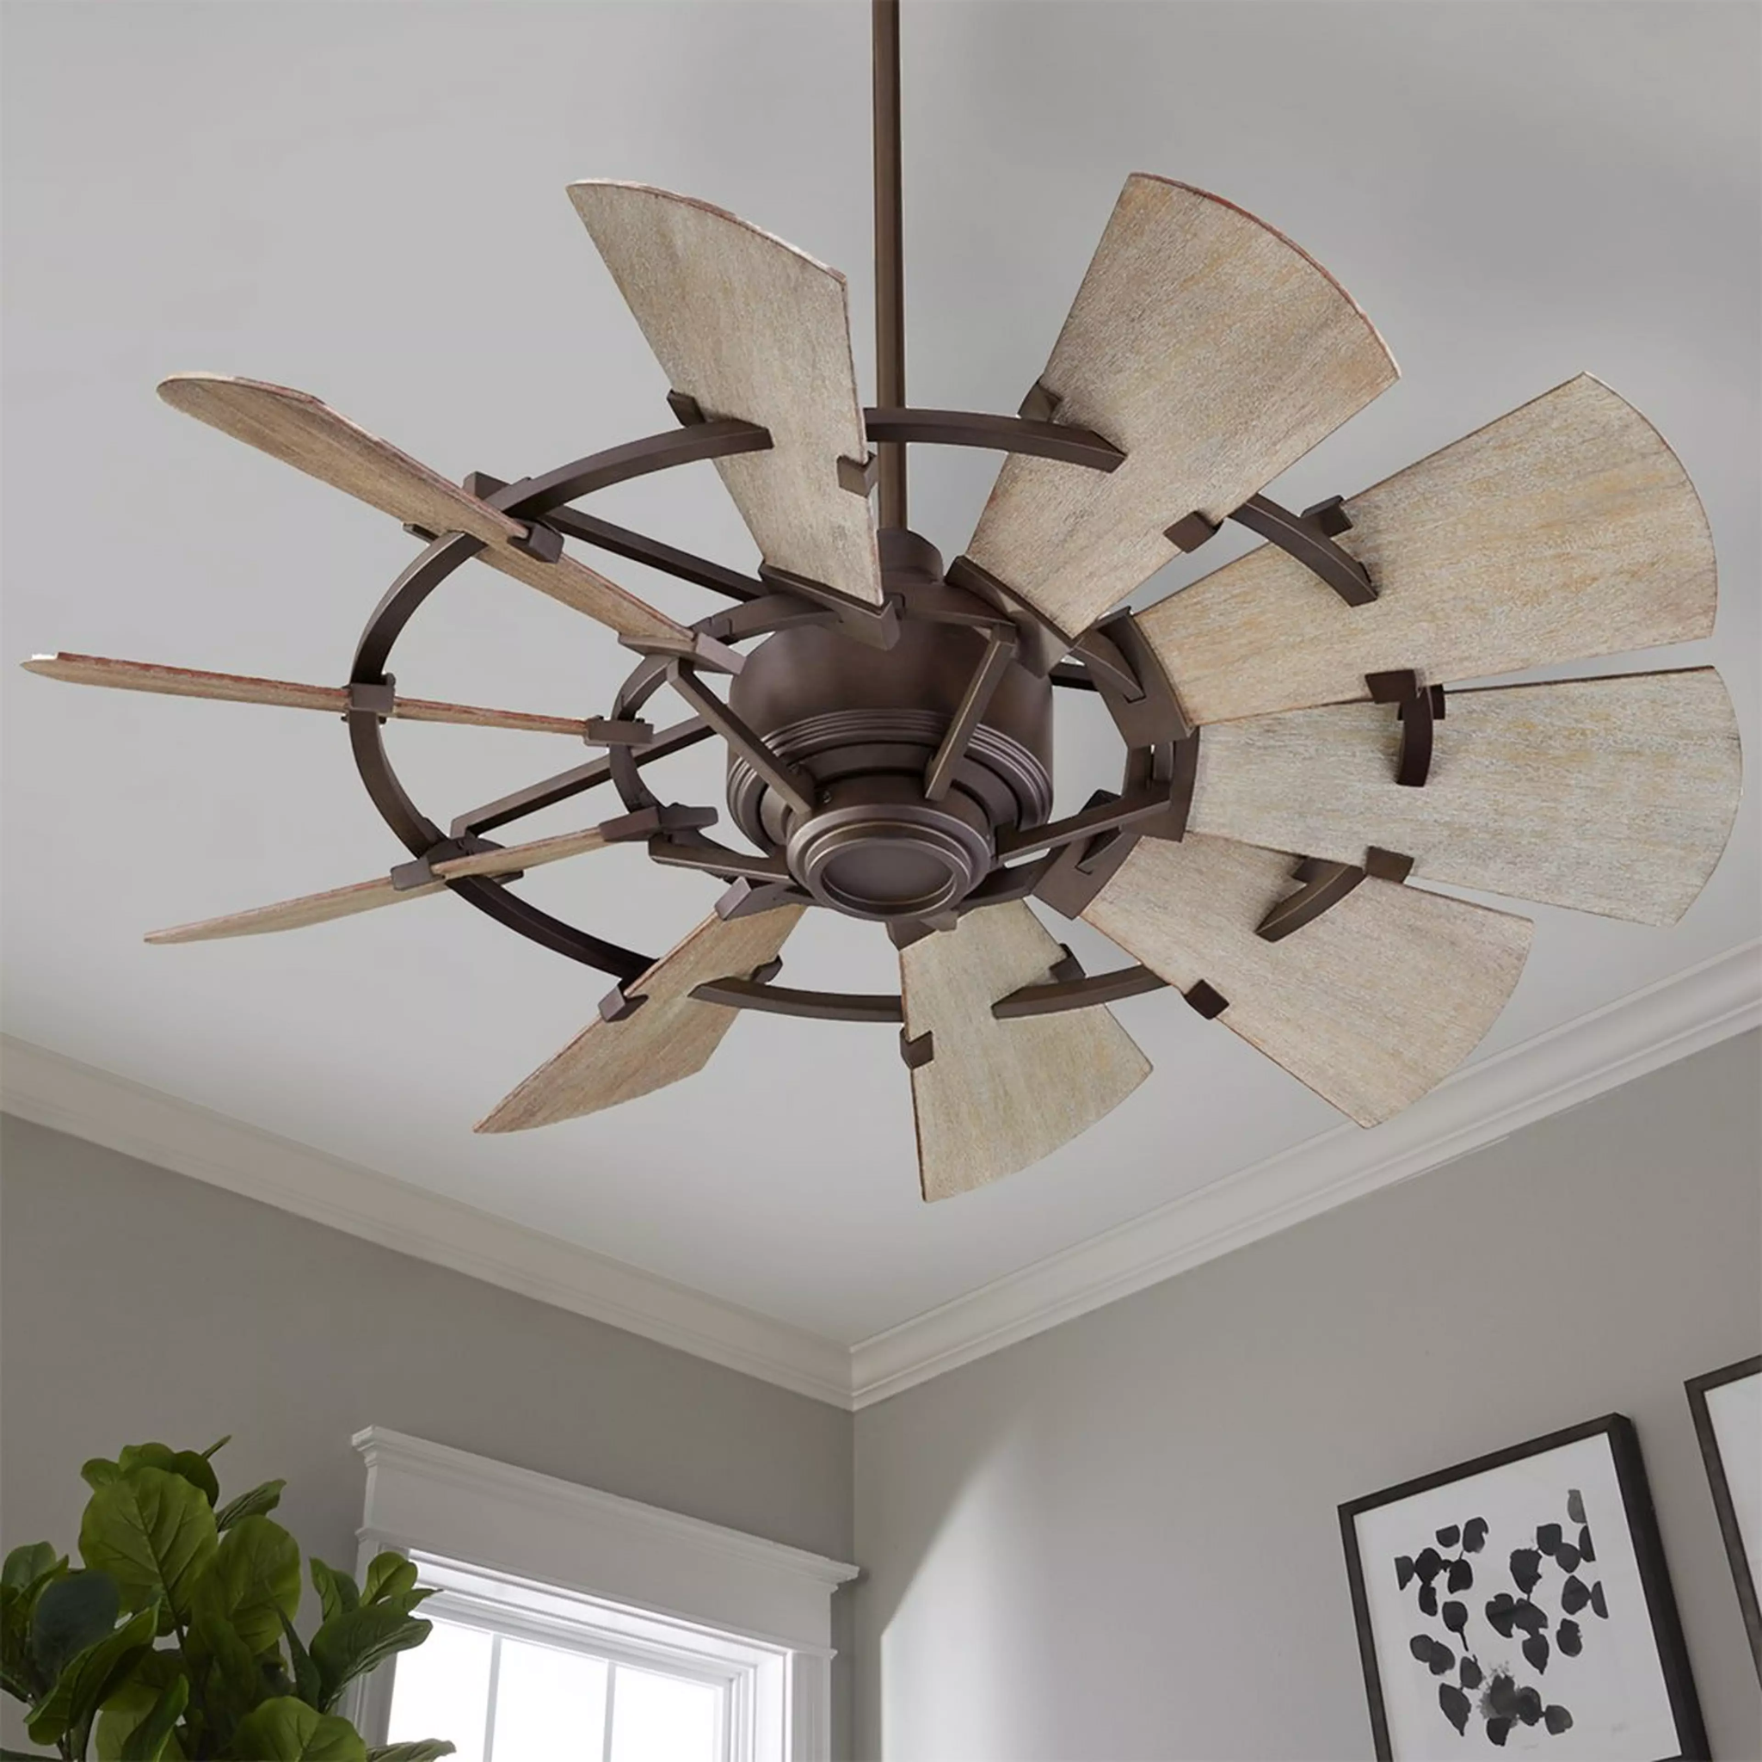
Figure 2: Fan Example - Ceiling Fan
Beyond just the blade of the fan, Nick requested for optimization of the hub of the fan as well as the number of blades in relation to the fan blade design. We were able to incorporate those variables into our optimization problem.

The objective of optimization is to find the combination of the curve and twist of the blade that will produce the maximum airflow through the fan. With the motor of the fan being predetermined by Nick, he requested we optimize the design of the fan blade and hub to increase efficiency. Starting with a Latin Hypercube Sample to seed the design space, we performed Bayesian optimization using Gaussian Processes to iteratively converge on the optimum.

Optimization Formulation and Product Modeling
For the optimization problem, design variables were chosen that affect the size of the blade and fan. These were split into two groups: airfoil parameters that affect the shape of the blade’s cross-section, and fan parameters that affect the shape and sizing of the fan when constructed with all the blades. Reasonable constraints were then chosen based on the allowable ranges that were able to generate in Solidworks without errors. The shroud surrounding the fan has already been finalized, so it was not included in the optimization formulation, though it is used for the simulation.

Design Variables
- Airfoil Parameters
  - Sweep of Fan: $θ (deg.)$
  - Chord Length: $L_{chord} (in)$
  - Max Camber Percent: $M_{Camber} (\%)$
  - Location of Max Camber Percent: $L_{Camber} (\%)$
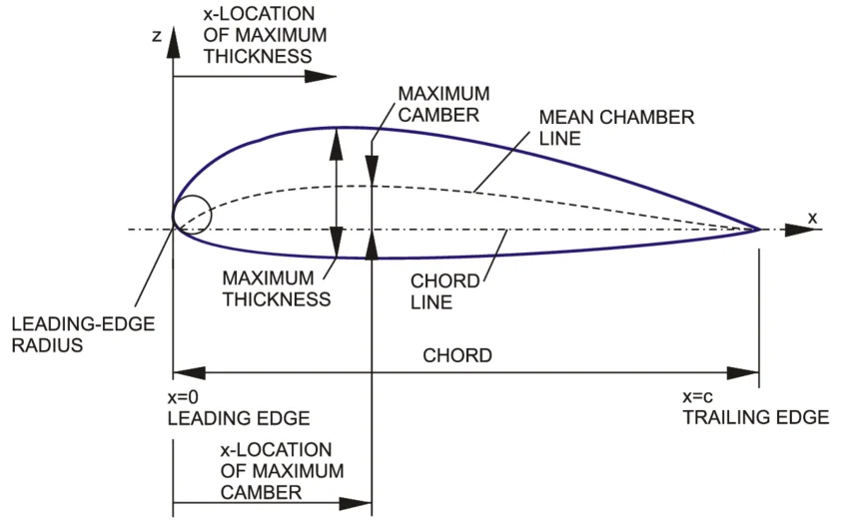
Figure 3. Airfoil Parameters Demonstration
- Fan Parameters
  - Hub Diameter: $D_{Hub} (in)$
  - Hub Thickness: $T_{Hub} (in)$
  - Max Fan Diameter: $D_{Fan} (in)$
  - Number of Blades: $N$
  - Angle of Attack: $α$
  - Speed of Fan: $ω (rad/s)$
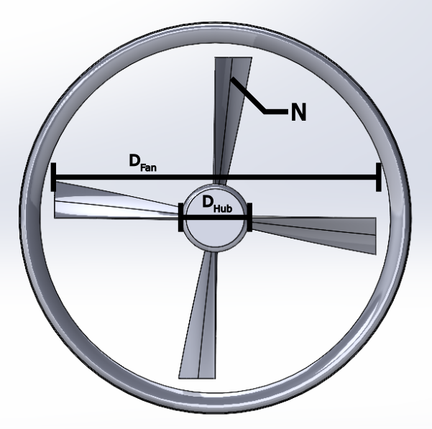
Figure 4. Fan Size Parameters in Model

Constraints
- Airfoil Parameters
  - Sweep of Fan: $0≤θ≤90$
  - Chord Length: $1≤L_{chord}≤10$
  - Max Camber Percent: $.01≤M_{Camber}≤.10$
  - Location of Max Camber Percent: $.3≤L_{Camber}≤.6$
- Fan Parameters
  - Hub Diameter: $2≤D_{Hub}≤8$
  - Hub Thickness: $8≤T_{Hub}≤9$
  - Max Fan Diameter: $33≤D_{Fan}≤35.5$
  - Number of Blades: $2≤N≤7$
  - Angle of Attack: $-85≤α≤-60$
  - Speed of Fan: $10≤ω≤100$

Objective

Volumetric Flow Rate of Air: $Q$

Airfoil Selection
The generalized NACA Four-digit airfoil was chosen based on research into existing fan design from the “Stanford - The NACA airfoil series,” textbook. Hence, the thickness distribution of the four-digit NACA airfoils was chosen as:
${±y}_{d}=\frac{d}{0.20}\left[0.2969\sqrt{\frac{x}{l}}-0.1260\left(\frac{x}{l}\right)-0.3516{\left(\frac{x}{l}\right)}^{2}+0.2843{\left(\frac{x}{l}\right)}^{3}-0.1015{\left(\frac{x}{l}\right)}^{4}\right]$
The mean camber line consists of two parabolic arcs with the two parameters f (maximum camber) and x_{f} (location of maximum camber):
$y_{s}=\frac{f}{x_{f}}\left(2x_{f}x-x^{2}\right)$ for $0≤x≤x_{f}$
$y_{s}=\frac{f}{{{(1-x}_{f})}^{2}}\left[\left(1-2x_{f}\right)+2x_{f}x-x^{2}\right]$ for $x_{f}≤x≤l$

The final coordinates for the airfoil upper surface (x_{U},y_{U}) and the lower surface (x_{L},y_{L}) are determined through the following equations:
$x_{U}=x-y_{d} sinθ$
$y_{U}=y_{s}+y_{d} cosθ$
$x_{L}=x+y_{d} sinθ$
$y_{L}=y_{s}-y_{d} sinθ$
where $θ=arctan\left(\frac{dy_{s}}{dx}\right)$

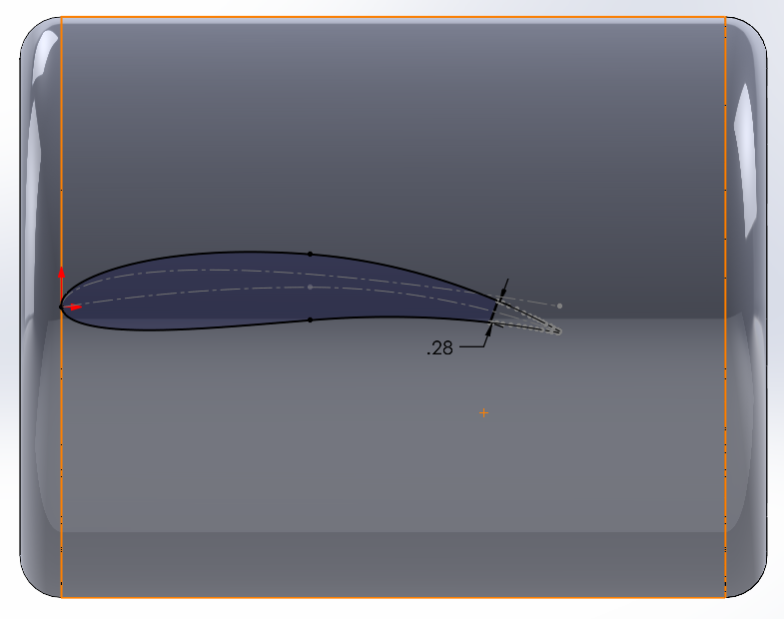
Figure 5. Example Airfoil Generation

Technical Background
This section will detail the technical aspects of the problem. This includes the sampling method used, surrogate models, and validation of models.

Latin Hypercube Sampling
To efficiently explore the high-dimensional design space of the axial fan, we implemented Latin Hypercube Sampling (LHS) using the scipy.stats.qmc module. Given the multi-parameter nature of the fan geometry, a structured sampling strategy was required to ensure uniform coverage without the combinatorial explosion associated with full-factorial approaches.

Methodology
The fan geometry was parameterized using a 10-dimensional design vector:
- $x_{1}$​: Hub Diameter
- $x_{2}$​: Maximum Fan Diameter
- $x_{3}$​: Maximum Camber (%)
- $x_{4}$​: Location of Maximum Camber (%)
- $x_{5}$​: Chord Length
- $x_{6}$​: Maximum Thickness (%)
- $x_{7}$​: Number of Blades
- $x_{8}$​: Hub Thickness
- $x_{9}$​: Angle of Attack
- $x_{10}$​: Twist Angle
Each parameter was bounded based on physical feasibility, prior design intuition, and manufacturing constraints. A 10-dimensional Latin hypercube was generated with $n$ = 100 samples, ensuring that each parameter range was stratified into equally probable intervals and sampled exactly once per interval.
The sampling process consisted of:
- Generating normalized samples in the unit hypercube [0,1]¹⁰.
- Scaling each dimension to its corresponding physical bounds.
- Enforcing discreteness for blade count ($x_{7}$​) via integer rounding.
This approach guarantees better space-filling properties compared to purely random sampling, particularly in higher dimensions, and reduces clustering or undersampling in critical regions of the design space.

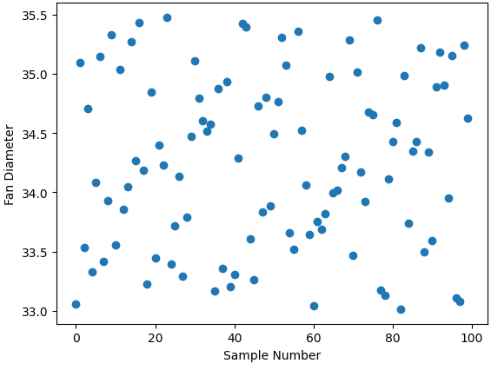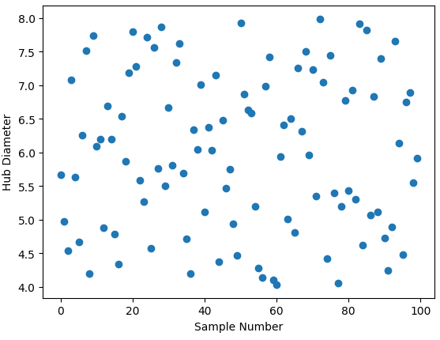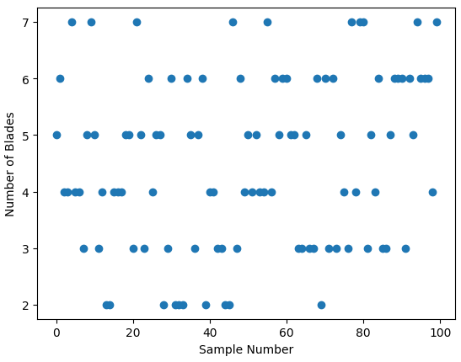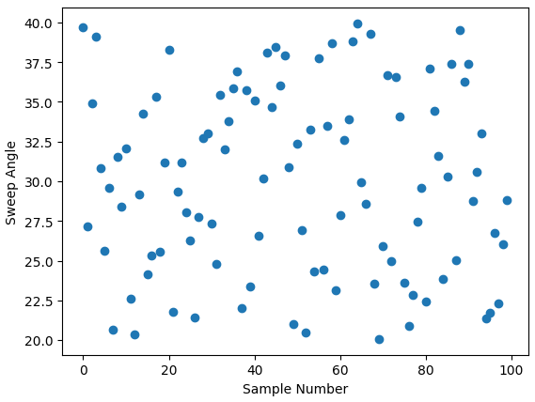
Figure 6. The sample points of some of the design variables.

Rationale for Use
LHS was selected over simple random sampling due to:
- Improved coverage of each design variable across its full range
- Reduced variance in performance estimation for a fixed number of samples
- Efficiency in capturing nonlinear interactions between geometric parameters
This was particularly important given the computational cost of CFD evaluations for each fan configuration. With coarse mesh, our simulations took about 20 minutes to run/

Application to Fan Optimization
The generated 100 design points were used as input geometries for CFD simulations to evaluate performance metrics such as volumetric flow rate (CFM), pressure rise, and efficiency. Since this initial dataset was generated via non-adaptive sampling, it serves as a baseline exploration of the design space.
Subsequent optimization steps can build on this dataset using:
- Surrogate modeling (e.g., Gaussian processes or neural networks)
- Bayesian optimization
Overall, LHS enabled a robust and computationally tractable initialization of the fan design optimization process, ensuring that early-stage insights were not biased by poor sampling of the parameter space.

Limitations of Sampling Integer Design Variables
While Latin Hypercube Sampling (LHS) provides strong space-filling properties for continuous variables, its application to integer-constrained parameters specifically the number of blades ($x_{7}$) introduced several limitations that affect the quality and interpretability of the design exploration.

Loss of Stratification
LHS ensures that each variable is sampled uniformly across its range by dividing it into equally probable intervals. However, because the number of blades must be an integer, the sampled continuous values were rounded to the nearest whole number. This rounding process disrupts the original stratification, as multiple samples from different intervals can collapse to the same integer value. As a result, the uniformity guaranteed by LHS in the continuous domain is no longer preserved for this variable.

Non-Uniform Distribution of Blade Counts
Due to the mismatch between continuous sampling and discrete rounding, the resulting distribution of blade counts is not perfectly uniform. Certain values may be overrepresented while others are underrepresented, depending on how the sampled values fall relative to integer boundaries. This leads to an uneven exploration of the discrete design space, as observed in the sample distribution.

Clustering Effects in the Design Space
The rounding process can also create artificial clustering, where multiple design points share the same number of blades but differ in other parameters. This results in dense regions of the design space corresponding to specific blade counts, while other regions remain sparsely sampled. Such clustering can bias downstream analyses, particularly when evaluating the influence of blade count on performance.

Implications for Analysis and Optimization
These limitations reduce the statistical robustness of comparisons between different blade counts. Since the sampling density is not uniform across discrete values, observed performance trends may reflect sampling artifacts rather than true physical behavior. This is especially important for fan design, where the number of blades can have a significant and nonlinear impact on flow rate, pressure generation, and efficiency.

Figure 7. Sample of the Number of Blades

Gaussian Process Optimization Framework
To refine our search for optimal fan designs, we implemented a Gaussian Process (GP)-based optimization framework that combined surrogate modeling, acquisition-driven sampling, and global optimization. This allowed us to iteratively identify promising design candidates while minimizing the number of CFD evaluations.

Data Preprocessing and Normalization
We began by loading the CFD dataset from the optimal latin hypercube and separating the input design variables from the target performance metric. To improve numerical stability and convergence of the GP model, we applied standardization:
- We normalized the input design variables to zero mean and unit variance
- We also scaled the output performance metric to ensure consistent magnitude
This preprocessing step was critical, as Gaussian Processes are sensitive to the relative scaling of inputs and outputs, particularly during hyperparameter optimization.

Gaussian Process Model Definition and Training
We defined the Gaussian Process using a Matérn kernel with ($ν$ = 2.5), which we selected due to its suitability for modeling physical systems with moderate smoothness and nonlinearity. We used a Gaussian Process as a non-parametric, probabilistic regression model to approximate the relationship between the fan design variables and a performance metric (e.g., CFM). Given a set of previously evaluated designs, the GP provided a predictive distribution at any new design point:
- A mean prediction: $μ(x)$, representing expected performance
- A standard deviation: $σ(x)$: representing prediction uncertainty
This formulation enabled us to explicitly quantify both:
- What we know (regions with high confidence)
- What we do not know (regions with high uncertainty)
To account for numerical noise in CFD simulations, we augmented the kernel with a WhiteKernel component.
- The Matérn kernel enabled us to capture complex, non-smooth relationships between design variables and performance
- The WhiteKernel allowed the model to handle small stochastic variations and numerical noise
We trained the GP on the scaled dataset and used multiple restarts of the optimizer to ensure robust convergence of kernel hyperparameters. This helped avoid local minima during likelihood maximization and improved the fidelity of the surrogate model.

Expected Improvement-Based Optimization
To guide the search for improved designs, we used the Expected Improvement (EI) acquisition function. At each candidate point, EI quantified the expected gain over the current best observed performance while incorporating model uncertainty.
$EI(x)=(μ(x)-f^{*})ϕ(Z)+σ(x)ϕ(Z), Z=\frac{μ(x)-f^{*}}{σ(x)}$
We computed EI using the GP-predicted mean and standard deviation. This allowed us to balance:
- Exploitation: by favoring regions with high predicted performance
- Exploration: by favoring regions with high uncertainty
To ensure numerical stability, we explicitly handled cases where the predicted uncertainty approached zero, preventing division-by-zero errors and ensuring physically meaningful behavior of the acquisition function.

Global Optimization of the Acquisition Function
We then optimized the EI function to determine the next candidate design point. Rather than relying on local optimization methods, we used differential evolution, a global optimization algorithm, to search the design space.
- The search was conducted in the normalized design space within ±2 standard deviations of the training data
- Differential evolution enabled robust exploration of the acquisition landscape, which is often non-convex and multimodal
By minimizing the negative EI, we effectively identified the design point with the highest expected improvement.
Once the optimal point in the normalized space was identified, we transformed it back to the original physical parameter space using the inverse scaling transformation. This provided a set of actionable fan design parameters that could be evaluated in CFD.
Overall, this approach significantly improved the efficiency of the design process by focusing computational resources on the most promising regions of the design space, enabling faster convergence toward optimal fan configurations. However, an opportunity for further improvement was explored with using bayesian optimization as a development on the GP and EI methodology.

Bayesian Optimization as an Improvement to the GP Optimization Framework
To further enhance the efficiency and robustness of our optimization workflow, we extended the Gaussian Process framework to a full Bayesian Optimization approach. While our initial implementation relied on optimizing the Expected Improvement (EI) acquisition function using differential evolution, this strategy treated each optimization step in isolation. In contrast, Bayesian Optimization allowed us to iteratively update the surrogate model and acquisition strategy in a closed-loop manner, improving convergence toward optimal fan designs.

Motivation for Bayesian Optimization
In the previous approach, we used differential evolution to globally optimize the EI function and identify a single promising candidate point. However, this method did not explicitly manage the sequential learning process across multiple iterations. As a result:
- Each optimization step did not fully leverage the evolving structure of the surrogate model
- The exploration–exploitation balance was not adaptively refined over successive samples
- The process lacked a systematic mechanism for updating the design strategy based on newly acquired data
To address these limitations, we implemented Bayesian Optimization as a higher-level framework around the Gaussian Process surrogate.

Bayesian Optimization Implementation
We defined the design space bounds directly in terms of the physical parameters (see Optimization Formulation).We then initialized the optimization process with an existing dataset ($x_{0}$,$y_{0}$), obtained from prior Latin Hypercube sampling and CFD-obtained objective values. Using a fixed random seed ensured reproducibility of the optimization trajectory.
The Bayesian Optimization routine was executed using about 75 iterations with the black box function.

At each iteration, the algorithm performed the following steps:
- Fit a Gaussian Process surrogate to all available data
- Construct an acquisition function (Expected Improvement) based on the updated surrogate
- Optimize the acquisition function to propose the next sampling point
- Evaluate the black-box function (CFD simulation) at the proposed point
- Augment the dataset with the new observation
This loop was repeated for a specified number of iterations, allowing the model to progressively refine its understanding of the design space. In addition, refitting the Gaussian Process with the new data each iteration

Analysis Models

Computational Fluid Dynamics
To evaluate the aerodynamic performance of various fan designs, we utilized Ansys Fluent as our high-fidelity analysis model. The simulation environment consisted of a fan assembly centered within a large-scale mock wind tunnel. This domain was sized to ensure that boundary effects did not interfere with the development of the flow field around the blades.

Simulation Inputs(Design Variables)
The CFD model is driven by a set of geometric and operational parameters. These variables define the search space for the optimization and are used to generate the Latin Hypercube Sample for surrogate model training. These variables are divided into two categories: geometric and operational. The geometric parameters, specifically sweep, chord, camber, and hub diameter, define the physical architecture of the fan. In contrast, the operational parameters, such as blade count and rotational speed, define the conditions under which the simulation is executed.

Airfoil Parameters
- Sweep: 0º to 90º
- Chord Length: 1 to 10 inches
- Max Camber Percent: 1% to 10%
- Location of Max Camber: 30% to 60% of Chord Length

Fan Parameters
- Hub Diameter: 2 to 8 inches
- Hub Thickness: 8 to 9 inches
- Max Fan Diameter: 24 to 33 inches
- Number of Blades: 2 to 16
- Angle of Attack: -85º to -60º
- Speed of Fan: 10 rpm to 100 rpm

Simulation Mesh(Objective Function)
Due to project time constraints, we adopted a hybrid meshing strategy consisting of a coarse mesh in the wind tunnel domain and a locally refined mesh within the moving reference frame (MRF) region. This approach reduced computational cost while preserving solution fidelity in the regions most critical to flow physics.
The following mesh settings were applied consistently across all samples and throughout the optimization process:
- Global Mesh Settings:
  - Element size: 2.056 m
  - Maximum size: 2.056 m
  - Adaptive sizing: Disabled
  - Growth rate: 1.2 (default)
  - Mesh defeaturing: Enabled
  - Defeature size: 0.001 m
- Curvature and Proximity Controls:
  - Capture curvature: Enabled
  - Curvature minimum size: 0.010 m
  - Curvature normal angle: 18.0°
  - Capture proximity: Disabled
- Refinement:
  - Applied within the moving reference frame region (finer mesh relative to the tunnel domain)
- Inflation Layers (Shroud Boundary in MRF Region):
  - Inflation option: Smooth transition
  - Transition ratio: 0.272 (default)
  - Maximum layers: 3
  - Growth rate: 1.2
  - Inflation algorithm: Pre
This meshing strategy ensured adequate boundary layer resolution near the shroud and improved accuracy in the rotating flow region, while maintaining manageable simulation runtimes.

Simulation Boundary Conditions
The team employed the k–ε turbulence model with standard wall functions, given its numerical robustness and suitability for steady-state simulations involving rotating machinery modeled with a moving reference frame (MRF). This model provided stable convergence behavior while capturing the dominant turbulent flow characteristics within the fan and shroud region.

The boundary conditions were held consistent across all simulations and are summarized below.

Table 1. Boundary Conditions specified to named selections following meshing
Type | Named Selection | Details
Fluid Zone | MRF | Material: Air  Frame Motion  Relative to cell zone: Absolute  Rotation-Axis Origin: (0.09 m, 0 m, 0 m)  Rotation-Axis Direction: (1, 0, 0)
Inlet | Inlet | Type: Pressure Inlet  Gauge Pressure: 0 Pa
Outlet | Outlet | Type: Pressure Outlet  Gauge Pressure: 0 Pa
Wall | Fan Blades | Wall Motion: Moving Wall  Motion: Relative to Adjacent Cell Zone (Rotational) Rotational-Axis Origin: (0,09 m, 0 m, 0 m)  Rotation-Axis Direction: (1, 0, 0)  Rotational Speed: 0 rad/s
Wall | Shroud | Wall Motion: Moving Wall  Motion: Absolute (Rotational)  Rotational-Axis Origin (0,09 m, 0 m, 0 m)  Rotation-Axis Direction (0, 0, 1)  Rotational: Speed 0 rad/s

Simulation Outputs(Objective Function)
The raw data from the Ansys Fluent solver is post-processed into discrete scalar values. The volumetric flow rate value serves as the objective function for our optimization formulation when returned to the program from Ansys.

Analysis of Results
The team developed an automated workflow in Python using Jupyter Notebook to parametrize and evaluate fan designs. The script interfaced with the SolidWorks API to open the part file and update the geometry based on the current set of design variables. After modifying the part, the assembly and corresponding fluid domain were regenerated, and the internal flow volume was exported as a Parasolid file.
Within the same workflow, ANSYS Workbench (Fluent) was programmatically launched. The updated geometry was imported into DesignModeler, followed by automated mesh generation and solution execution in Fluent. Upon completion of each simulation, the script extracted the volume flow rate as the primary output parameter for use in the optimization loop.

Identification of Optimal Design

Differential Evolution Training of the Gaussian Process Surrogate Model
Using the differential evolution with the training of the Gaussian Process, the optimal obtained was:
- Sweep: 31.26º
- Chord Length: 2.66 in
- Max Camber Percent: 0.288
- Max Thickness Percent: 0.259
- Location of Max Camber: 0.305
- Hub Diameter: 4.94 in
- Hub Thickness: 8.77 in
- Max Fan Diameter: 34.77 in
- Number of Blades: 6
- Angle of Attack: -62.52º
- Speed of Fan: 20.94 rad/s
This configuration yielded a volumetric flow rate of 15.93 m³/s, which is significantly lower than the ~20 m³/s achieved by several designs sampled via Latin Hypercube Sampling (LHS). Since the optimizer is operating on the surrogate model rather than the true CFD response, this discrepancy indicates deficiencies in the Gaussian Process model fidelity. This issue was likely due to:
- Poor training data coverage: The LHS dataset may not sufficiently cover high- perfomring regions of the design space.
- Model Underfitting or Over-Smoothing: GP hyperparameters (e.g. kernel length scales) may be too large, leading to an overly smooth response surface that suppresses peaks in performance.
- High Noise and Numerical Variability in CFD Outputs: Due to the coarse mesh used, the simulation outputs may be noisy so the GP may interpret this as stochastic behavior and fail to learn meaningful trends.
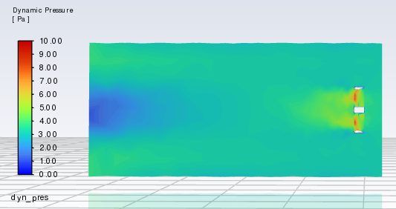
Figure 8. Dynamic Pressure Contour along the mid plane
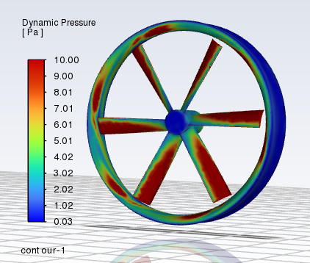
Figure 9. Dynamic Pressure Contour on the Surface of the fan blades and the shroud.

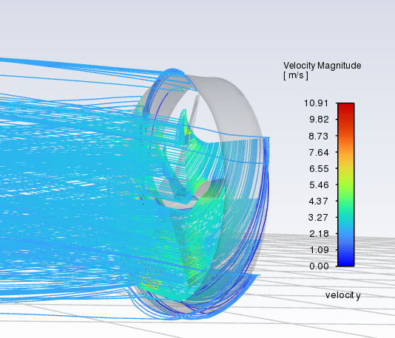
Figure 10. Velocity Pathlines in Moving Reference Frame.
As mentioned before, Bayesian Optimization was used as an improvement on the shortcomings of the differential evolution training of the Gaussian Process of the 100 LHS Samples. By computing the value of the black-box CFD function for more design points, uncertainty in the optimal solution was reduced and a more optimal solution was found.
This resulted in the following updated Volumetric Flow Rate of Different Samples plot.
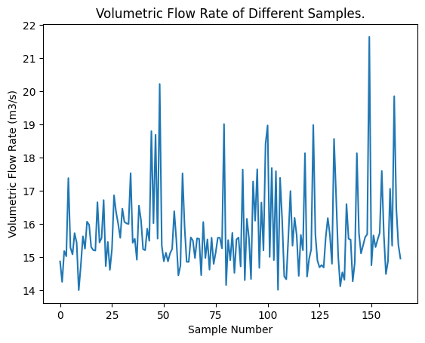
Figure 11. Volumetric Flow Rate of Different Samples. All sample number above 100 are from Bayesian Optimization.
This resulted in a maximum Volumetric Flow Rate of 21.64 m³/s which is a big improvement from the 20.88 m³/s obtained during the simulation of the LHS samples. Based on this improvement, the team concluded that Bayesian Optimization for this design problem was better than only relying on the training of the surrogate model. The optimal value was obtained from the parameters:
- Sweep: 37.27º
- Chord Length: 4.19 in
- Max Camber Percent: 0.163
- Max Thickness Percent: 0.152
- Location of Max Camber:0.230
- Hub Diameter: 6.73 in
- Hub Thickness: 8.06 in
- Max Fan Diameter: 33.56 in
- Number of Blades: 6
- Angle of Attack: -69.99º
- Speed of Fan: 20.94 rad/s

Verification and Validation

Verification of Numerical Implementation
Before running any true simulations and optimization, to ensure that the CFD model was numerically sound, we performed a study with an extremely coarse mesh to ensure that the volumetric flow rate converged. The initial project scope included an experimental validation phase, where the simulated CFD results were to be verified using a physical wind tunnel. However, due to the tight time constraints of the course, we were unable to further investigate this opportunity.

Validation of Result
In order to validate the simulations to the physics of real life, we inspected the pressure contours throughout the fan to cross reference the pressure gradient to physical intuition. Namely, the CFD results were qualitatively validated through inspection of the pressure distributions both in the tunnel and on the fan itself. Looking at the dynamic pressure contour along the mid plane in figure 12, there is a clear jet being formed behind the fan(right to left). As the fan takes in air and shoots it out of the outlet, there is a jump in pressure at the fan blades. As the air travels through the wind tunnel and interacts with the relatively still air inside the tunnel, the energy gets spread out and slows down. Lower dynamic pressure on the left means that the air is slowing back down as it reaches the other end of the wind tunnel.

Figure 12. Dynamic Pressure Contour along the Mid-Plane
As well as analyzing the dynamic pressure along the mid plane through the wind tunnel, we also looked closely at the dynamic pressure on the fan blades themselves. As seen in figure 13, the peak dynamic pressure(dark red) is concentrated on the leading edge and the outer tips of the blade. It makes physical sense for the leading edge of the fan blade to experience a maximum dynamic pressure since this is where the blade makes first contact with the air. Additionally, it also makes physical sense for the outer tips of the blade to experience a higher pressure since the tangential velocity is greater on the outside than the inside due to the radial distance. As a result, we were able to verify our model with physical intuition.

Figure 13. Dynamic Pressure Contour on the Surface of the Fan Blades and the Shroud.

Verification of Global Optimality
Due to limited computational resources, it is difficult to verify whether the optimal solution that has been reached is a local or global optimum for the problem. By optimizing the expected values of the Gaussian Process function, it is possible to find an expected optimal point, but this may not be the true optimal point for the optimization problem. In addition, the high dimensionality of this problem reduced confidence that the true global optimum would be found in such a way. With additional computing resources and further iteration of the Bayesian Optimization algorithm, confidence in the validity of the optimal solution would increase.

Conclusion and Future Work

This project provided both technical depth and practical insight into aerodynamic design optimization workflows. A key success was the generation of parametric design of the airfoil geometry using the NACA 4 series equations and the integration of the SolidWorks API to parametrically modify fan geometry. This enabled rapid design iteration and established a scalable pipeline linking CAD and CFD, which is critical for high-dimensional design exploration.

From a simulation standpoint, implementing a Moving Reference Frame (MRF) approach allowed us to approximate rotating fan behavior under steady-state conditions. While not fully transient, this method provided a computationally efficient way to capture the essential flow physics around the blades and shroud, significantly reducing simulation cost while maintaining reasonable fidelity.

On the optimization side, the project deepened our understanding of Gaussian Process (GP) modeling and the Expected Improvement (EI) acquisition function. These tools formed the basis of our Bayesian Optimization framework, allowing us to intelligently explore the design space rather than relying solely on brute-force sampling. However, in practice, the baseline implementation of Bayesian Optimization did not consistently converge to a clear global optimum. This highlighted the sensitivity of GP-based methods to initial sampling, hyperparameter tuning, and noise in CFD outputs.

Several challenges also shaped our learning. Initially, we attempted a Fractional Factorial Design of Experiments (DOE) approach across 10 design variables, which proved impractical due to the combinatorial complexity and insufficient resolution of nonlinear interactions. This reinforced the limitations of classical DOE methods in high-dimensional, highly coupled design spaces.

Interestingly, the best-performing design was ultimately identified through Latin Hypercube Sampling (LHS), rather than Bayesian Optimization. This outcome emphasized that, for complex and noisy engineering problems, space-filling methods can sometimes outperform more sophisticated optimization techniques, particularly when the surrogate model struggles to accurately represent the response surface.

Overall, the project underscored the importance of combining robust geometry automation, efficient simulation strategies, and carefully selected optimization methods. It also highlighted that no single approach is universally optimal; instead, successful engineering design often requires iterative refinement and hybrid strategies that balance exploration, exploitation, and computational cost.

References
RoboMechMinds. RoboMechMinds GitHub Repository. Available at: https://github.com/RoboMechMinds

PyAnsys. PyAnsys Documentation. Available at: https://docs.pyansys.com/

Fans: Aerodynamic Design - Noise Reduction - Optimization. Carolus, T. (2023). Fans: Aerodynamic Design - Noise Reduction - Optimization. Springer Nature.

The NACA Airfoil Series. Cantwell, B. (Stanford University). The NACA Airfoil Series. Available at: https://web.stanford.edu/~cantwell/AA200_Course_Material/The%20NACA%20airfoil%20series.pdf

Huijskens, T. Bayesian Optimization Explained. Available at: https://thuijskens.github.io/2016/12/29/bayesian-optimisation/

Statement of Using AI Tools
Google Gemini was used to assist in generating portions of the code for training the Gaussian Process surrogate model.
Additionally, AI tools such as ChatGPT and Google Gemini were used in a limited capacity to troubleshoot errors encountered during the development and execution of the Jupyter Notebook workflow.

Appendix

Computer Codes
import matplotlib.pyplot as plt
from sklearn.model_selection import train_test_split
import sklearn.gaussian_process as gp
from sklearn.model_selection import cross_val_score
from sklearn.svm import SVR
%matplotlib inline

# Load the Python scripts that contain the Bayesian optimization code
%run "C:\Users\dtg0127\OneDrive - Northwestern University\441 Fan Design CAD & CAE & Code\optimization_code\code_and_libraries\Scripts\gp.py"
%run "C:\Users\dtg0127\OneDrive - Northwestern University\441 Fan Design CAD & CAE & Code\optimization_code\code_and_libraries\Scripts\plotters.py"
def expected_improvement(x, gaussian_process, evaluated_loss, greater_is_better=True, n_params=1):
""" expected_improvement

Expected improvement acquisition function.

Arguments:
----------
x: array-like, shape = [n_samples, n_hyperparams]
The point for which the expected improvement needs to be computed.
gaussian_process: GaussianProcessRegressor object.
Gaussian process trained on previously evaluated hyperparameters.
evaluated_loss: Numpy array.
Numpy array that contains the values off the loss function for the previously
evaluated hyperparameters.
greater_is_better: Boolean.
Boolean flag that indicates whether the loss function is to be maximised or minimised.
n_params: int.
Dimension of the hyperparameter space.

"""

x_to_predict = x.reshape(-1, n_params)

mu, sigma = gaussian_process.predict(x_to_predict, return_std=True)

if greater_is_better:
loss_optimum = np.max(evaluated_loss)
else:
loss_optimum = np.min(evaluated_loss)

scaling_factor = (-1) ** (not greater_is_better)

# In case sigma equals zero
with np.errstate(divide='ignore'):
Z = scaling_factor * (mu - loss_optimum) / sigma
expected_improvement = scaling_factor * (mu - loss_optimum) * norm.cdf(Z) + sigma * norm.pdf(Z)
expected_improvement[sigma == 0.0] == 0.0

# print(f"The EI right now is {expected_improvement}")
EI_list.append(expected_improvement)

return -1 * expected_improvement

def sample_next_hyperparameter(acquisition_func, gaussian_process, evaluated_loss, greater_is_better=True,
bounds=(0, 10), n_restarts=25):
""" sample_next_hyperparameter

Proposes the next hyperparameter to sample the loss function for.

Arguments:
----------
acquisition_func: function.
Acquisition function to optimise.
gaussian_process: GaussianProcessRegressor object.
Gaussian process trained on previously evaluated hyperparameters.
evaluated_loss: array-like, shape = [n_obs,]
Numpy array that contains the values off the loss function for the previously
evaluated hyperparameters.
greater_is_better: Boolean.
Boolean flag that indicates whether the loss function is to be maximised or minimised.
bounds: Tuple.
Bounds for the L-BFGS optimiser.
n_restarts: integer.
Number of times to run the minimiser with different starting points.

"""
best_x = None
best_acquisition_value = 1
n_params = bounds.shape[0]

for starting_point in np.random.uniform(bounds[:, 0], bounds[:, 1], size=(n_restarts, n_params)):

res = minimize(fun=acquisition_func,
x0=starting_point,
bounds=bounds,
method='L-BFGS-B',
args=(gaussian_process, evaluated_loss, greater_is_better, n_params))

if res.fun < best_acquisition_value:
best_acquisition_value = res.fun
best_x = res.x

return best_x

def bayesian_optimisation(n_iters, sample_loss, bounds, x0, y0,
gp_params=None, random_search=False, alpha=1e-5, epsilon=1e-7):
""" bayesian_optimisation

Uses Gaussian Processes to optimise the loss function `sample_loss`.

Arguments:
----------
n_iters: integer.
Number of iterations to run the search algorithm.
sample_loss: function.
Function to be optimised.
bounds: array-like, shape = [n_params, 2].
Lower and upper bounds on the parameters of the function `sample_loss`.
x0: array-like, shape = [n_pre_samples, n_params].
Array of initial points to sample the loss function for. If None, randomly
samples from the loss function.
n_pre_samples: integer.
If x0 is None, samples `n_pre_samples` initial points from the loss function.
gp_params: dictionary.
Dictionary of parameters to pass on to the underlying Gaussian Process.
random_search: integer.
Flag that indicates whether to perform random search or L-BFGS-B optimisation
over the acquisition function.
alpha: double.
Variance of the error term of the GP.
epsilon: double.
Precision tolerance for floats.
"""

x_list = []
y_list = []

n_params = bounds.shape[0]

for index in range(len(x0[:,0])):
x_list.append(x0[index,:])
y_list.append(y0[index])

xp = np.array(x_list)
yp = np.array(y_list)

# Create the GP
if gp_params is not None:
model = gp.GaussianProcessRegressor(**gp_params)
else:
kernel = gp.kernels.Matern()
model = gp.GaussianProcessRegressor(kernel=kernel,
alpha=alpha,
n_restarts_optimizer=10,
normalize_y=True)

for n in range(n_iters):

model.fit(xp, yp)

# Sample next hyperparameter
if random_search:
x_random = np.random.uniform(bounds[:, 0], bounds[:, 1], size=(random_search, n_params))
ei = -1 * expected_improvement(x_random, model, yp, greater_is_better=True, n_params=n_params)
next_sample = x_random[np.argmax(ei), :]
else:
next_sample = sample_next_hyperparameter(expected_improvement, model, yp, greater_is_better=True, bounds=bounds, n_restarts=100)

# Duplicates will break the GP. In case of a duplicate, we will randomly sample a next query point.
if np.any(np.abs(next_sample - xp) <= epsilon):
next_sample = np.random.uniform(bounds[:, 0], bounds[:, 1], bounds.shape[0])

# Sample loss for new set of parameters
print(next_sample)
cv_score = sample_loss(next_sample)

# Update lists
x_list.append(next_sample)
y_list.append(cv_score)

# Update xp and yp
xp = np.array(x_list)
yp = np.array(y_list)

return xp, yp
import time
import win32com.client
import pythoncom
import math
import subprocess as sb
import numpy as np
# import sys
# print(sys.executable)

def update_Equation(index_num ,var_name, var_val, theEquationMgr):
equation_string = f'{var_name} = {var_val}'
result = theEquationMgr.SetEquationAndConfigurationOption(index_num, equation_string, 2, None)

if result != -1:
# print(f'{var_name} successfully updated')
pass
else:
print("Update failed!")
return

def change_geometry(eqn_names, eqn_vals, twistAngleVal):
if len(eqn_names) != len(eqn_names):
raise ValueError("Length of the equation names and the equation values must be the same")

# start SolidWorks
# sb.Popen(r"C:\Program Files\SOLIDWORKS Corp\SOLIDWORKS (2)\SLDWORKS.exe")

# time.sleep(30) # wait for solidworks to load

# connecting Python to SolidWorks
# swApp = win32com.client.Dispatch("SLDWORKS.Application")
# swApp.Visible = True

# arg1 = win32com.client.VARIANT(16387, 0)

# open a document
FanPart = swApp.OpenDoc6(r"C:\Users\dtg0127\OneDrive - Northwestern University\441 Fan Design CAD & CAE & Code\Run_Samples\N1_20\FanV3.SLDPRT", 1, 0, "", arg1, arg1)

swEquationMgr = FanPart.GetEquationMgr

only_read = FanPart.IsOpenedReadOnly
# if only_read != True:
# print("File is editable")
# else:
# raise TypeError("Cannot edit file")

for ind in range(len(eqn_names)):
update_Equation(ind, eqn_names[ind], eqn_vals[ind], swEquationMgr)

FanPart.EditRebuild3

# change_twistAngle(twistAngleVal )

curFeature = FanPart.FeatureByName("Sweep1")
featData = curFeature.GetDefinition

isGood = featData.AccessSelections(FanPart, pythoncom.Nothing)

twist_angle_rad = twistAngleVal * math.pi / 180
featData.SetTwistAngle(twist_angle_rad)

curFeature.ModifyDefinition(featData, FanPart, pythoncom.Nothing)
featData.ReleaseSelectionAccess()

saveStatus = FanPart.Save3(0, arg1, arg1)

# if saveStatus == True:
# print("Fan Part File saved successfully")
# else:
# print("Fan Part File save Failed")

tunnelAssem = swApp.OpenDoc6(r"C:\Users\dtg0127\OneDrive - Northwestern University\441 Fan Design CAD & CAE & Code\Run_Samples\N1_20\TunnelFanShroudAssembly.SLDASM", 2, 0, "", arg1, arg1)

tunnelAssem.EditRebuild3

saveStatus = tunnelAssem.Save3(4, arg1, arg1)

# if saveStatus == True:
# print("Assem File saved successfully")
# else:
# print("Assem File Save Failed")

swApp.CloseDoc("FanV3.SLDPRT")
swApp.CloseDoc("TunnelFanShroudAssembly.SLDASM")

tunnelPart = swApp.OpenDoc6(r"C:\Users\dtg0127\OneDrive - Northwestern University\441 Fan Design CAD & CAE & Code\Run_Samples\N1_20\Tunnel_MRF.SLDPRT", 1, 0, "", arg1, arg1)

saveStatus = tunnelPart.Save3(0, arg1, arg1)

# if saveStatus == True:
# print("Tunnel Part File saved successfully")
# else:
# print("Tunnel Part Save Failed")

parasolidStatus = tunnelPart.SaveAs3(r"C:\Users\dtg0127\OneDrive - Northwestern University\441 Fan Design CAD & CAE & Code\Run_Samples\N1_20\Parasolid Files\Tunnel_MRF.x_t", 0, 0)
# if parasolidStatus == False:
# print("File exported successfully")
# else:
# print("Export Failed")

swApp.CloseDoc("Tunnel_MRF.SLDPRT")
# swApp.ExitApp()

return

def black_box_function(params):
"""
x1: HubDiameter
x2: MaxFanDiameter
x3: MaximumCamberPercent
x4: LocationMaxCamberPercent
x5: ChordLength
x6: MaxThicknessPercent
x7: NumberOfBlades
x8: HubThickness
x9: AngleOfAttack
x10: TwistAngle
"""
x1=params[0]
x2=params[1]
x3=params[2]
x4=params[3]
x5=params[4]
x6=params[5]
x7=np.round(params[6]) # round the number of blades
x8=params[7]
x9=params[8]
x10=params[9]
"""Function with unknown internals we wish to maximize.

This is just serving as an example, for all intents and
purposes think of the internals of this function, i.e.: the process
which generates its output values, as unknown.
"""
eqn_names1 = ['"HubDiameter"',
'"MaxFanDiameter"',
'"D1@Sketch1"', # DO NOT CHANGE
'"MaxFanThickness"', # DOES NOT DO ANYTHING
'"D1@Bound" ', # DO NOT CHANGE
'"FanThickness"', # DOES NOT DO ANYTHING
'"MaximumCamberPercent"',
'"LocationMaxCamberPercent"',
'"ChordLength"',
'"MaxThicknessPercent"',
'"MaxCamber"',
'"LocationMaxCamber"',
'"MaxThickness"',
'"NumberOfBlades"',
'"D1@CirPattern1" ', # DO NOT CHANGE
'"HubThickness"',
'"D1@Sketch2"', # DO NOT CHANGE
'"AngleOfAttack"',
'"D1@Sketch9"', # DO NOT CHANGE
'"D2@Sketch2"'] # DO NOT CHANGE

"""General template
eqn_vals = [' 5in',
' 33in',
'"MaxFanDiameter"', # DO NOT CHANGE
' 7in',
' "MaxFanThickness"', # DO NOT CHANGE
' 6in',
' 0.1',
' 0.6',
' 4in',
' 0.15',
' "MaximumCamberPercent" * "ChordLength"', # DO NOT CHANGE
' "LocationMaxCamberPercent" * "ChordLength"', # DO NOT CHANGE
' "MaxThicknessPercent" * "ChordLength"', ' 4', # DO NOT CHANGE
' "NumberOfBlades"', # DO NOT CHANGE
' 8in',
'"HubThickness"', # DO NOT CHANGE
' 15deg', # DOES NOT DO ANYTHING
'"MaxFanDiameter"/2', '"HubDiameter"/2']
"""
eqn_vals1 = [f' {x1}in',
f' {x2}in',
'"MaxFanDiameter"', # DO NOT CHANGE
' 7in', # DOES NOT DO ANYTHING
' "MaxFanThickness"', # DO NOT CHANGE
' 6in', # DOES NOT DO ANYTHING
f' {x3}',
f' {x4}',
f' {x5}in',
f' {x6}',
' "MaximumCamberPercent" * "ChordLength"', # DO NOT CHANGE
' "LocationMaxCamberPercent" * "ChordLength"', # DO NOT CHANGE
' "MaxThicknessPercent" * "ChordLength"',
f' {x7}', # DO NOT CHANGE
' "NumberOfBlades"', # DO NOT CHANGE
f' {x8}in',
'"HubThickness"', # DO NOT CHANGE
f' {x9}deg',
'"MaxFanDiameter"/2', # DO NOT CHANGE
'"HubDiameter"/2'] # DO NOT CHANGE

twistAngleVal1 = x10

change_geometry(eqn_names1, eqn_vals1, twistAngleVal1)

return run_simulation()

def run_simulation():
from ansys.workbench.core import launch_workbench

wb = launch_workbench()

wb.run_script_string("""
Open(FilePath=r"C:\\Users\\dtg0127\\Downloads\\March9.wbpj")
system1 = GetSystem(Name="FFF")
geometry1 = system1.GetContainer(ComponentName="Geometry")
geometry1.Edit()

# Run commands inside DesignModeler
geometry1.SendCommand(Command='''
var selected_import;
selected_import = ag.gui.TreeviewFeature('Import1', 0)
selected_import.Name = 'Import1'
selected_import.Refresh = 1
agb.Regen();
''')

geometry1.Exit()

meshComponent1 = system1.GetComponent(Name="Mesh")
meshComponent1.Update(AllDependencies=True)

setup1 = system1.GetContainer(ComponentName="Setup")
setup1.Edit()

# Now the TUI commands have a clean slate to work on
setup1.SendCommand(Command='''
/file/set-tui-version "24.2"
(cx-gui-do cx-activate-item "Ribbon*Frame1*Frame5(Solution)*Table1*Table3(Initialization)*PushButton6(Initialize)")
(cx-gui-do cx-activate-item "Ribbon*Frame1*Frame5(Solution)*Table1*Table3(Run Calculation)*PushButton7(Calculate)")
''')

setup1.Exit()
""")

extract_output1 = """import json
p = Parameters.GetParameter(Name="P1")
my_tag = p.DisplayText
wb_script_result = json.dumps(my_tag + ',' + str(p.Value))
"""

Vresult_str = wb.run_script_string(extract_output1).split(',')[1].split(' ')[0]
Vresult_num = abs(float(Vresult_str))
# print("Result:",CFMresult_num, "CFM")

extract_output4 = """import json
p = Parameters.GetParameter(Name="P4")
my_tag = p.DisplayText
wb_script_result = json.dumps(my_tag + ',' + str(p.Value))
"""

Presult_str = wb.run_script_string(extract_output4).split(',')[1].split(' ')[0]
Presult_num = abs(float(Presult_str))
# print("Result:",CFMresult_num, "CFM")

extract_output3 = """import json
p = Parameters.GetParameter(Name="P3")
my_tag = p.DisplayText
wb_script_result = json.dumps(my_tag + ',' + str(p.Value))
"""

omega_str = wb.run_script_string(extract_output3).split(',')[1].split(' ')[0]
omega_num = abs(float(omega_str))
# print("Result:",CFMresult_num, "CFM")

M_s = 296474.56 # motor torque
P_s = 2*math.pi*M_s*omega_num

wb.exit()

return Vresult_num
xp, yp = bayesian_optimisation(n_iters=100, sample_loss=black_box_function,
bounds=bounds,
x0=x_new,y0=y_new)

xp_hat = xp[np.array(yp).argmax(), :]
yp_hat = yp[np.array(yp).argmax()]
print(xp_hat)
print(yp_hat)

bo_optimization_result = np.column_stack((xp, yp))
print("New size", np.shape(bo_optimization_result))

act_run_num = run_num+1

save_file_location = rf"C:\Users\dtg0127\OneDrive - Northwestern University\441 Fan Design CAD & CAE & Code\Run_Samples\last_chance{act_run_num}.txt"
np.savetxt(save_file_location, bo_optimization_result)

x_new = xp
y_new = yp
import numpy as np
import pandas as pd
from sklearn.gaussian_process import GaussianProcessRegressor
from sklearn.gaussian_process.kernels import Matern, WhiteKernel
from sklearn.preprocessing import StandardScaler
from scipy.stats import norm
from scipy.optimize import differential_evolution

# 1. Load the data
# We use pandas to read the text file. 'sep=None' lets it auto-detect tabs/commas/spaces.
data = pd.read_csv('results.txt', sep=None, engine='python')

# We split the data into X (inputs) and y (the CFD result)
# We assume the last column is the objective we want to MAXIMIZE
X_raw = data.iloc[:, :-1].values
y_raw = data.iloc[:, -1].values.reshape(-1, 1)

# 2. Pre-processing
# GPs work best when data is scaled. We normalize X to mean 0 and variance 1.
scaler_X = StandardScaler()
X_scaled = scaler_X.fit_transform(X_raw)

# We also scale y to help the GP optimizer converge faster
scaler_y = StandardScaler()
y_scaled = scaler_y.fit_transform(y_raw).flatten()

# 3. Define and Train the Gaussian Process
# We use a Matern kernel (nu=2.5) which is ideal for physical simulations.
# WhiteKernel handles the small numerical noise inherent in CFD.
kernel = Matern(nu=2.5) + WhiteKernel(noise_level=1e-5)
gp = GaussianProcessRegressor(kernel=kernel, n_restarts_optimizer=10)
gp.fit(X_scaled, y_scaled)

# 4. Define the Expected Improvement (EI) Acquisition Function
def expected_improvement(x, gp, y_max):
# Reshape x to match the input format expected by GP
x = x.reshape(1, -1)

# Get the predicted mean (mu) and standard deviation (sigma)
mu, sigma = gp.predict(x, return_std=True)

# Calculate how much we expect to improve over our current best (y_max)
# This formula balances searching near the current best vs. exploring unknown areas
with np.errstate(divide='warn'):
imp = mu - y_max
Z = imp / sigma
ei = imp * norm.cdf(Z) + sigma * norm.pdf(Z)
ei[sigma == 0.0] = 0.0

return -ei # Negated because we will use a minimizer to find the maximum

# 5. Optimize to find the next "Best" point
# We find the current best value in our training data
current_best_y = np.max(y_scaled)

# Define the boundaries for the search (min and max of your original data)
bounds = [(-2, 2)] * X_scaled.shape[1] # Search within +/- 2 standard deviations

# Use differential evolution (a global optimizer) to find the peak of the EI function
result = differential_evolution(expected_improvement, bounds, args=(gp, current_best_y))

# 6. Convert the found point back to original physical units
optimal_scaled = result.x.reshape(1, -1)
optimal_physical = scaler_X.inverse_transform(optimal_scaled)

print(f"The predicted optimal input parameters are: {optimal_physical}")

